AMERICAN INTERNATIONAL UNIVERSITY-BANGLADESH (AIUB)

Fall 2022-23, CSC 2211: Algorithms, Assignment No.: 02

|  |  |
| --- | --- |
| **Name:** | **ID:** |
| **Signature** | **Section:** |

1. Use dynamic programming to find the optimal solution to the 0/1 knapsack problem for a given set of items and knapsack capacity = 16 kg.

|  |  |  |  |  |
| --- | --- | --- | --- | --- |
| Item | 1 | 2 | 3 | 4 |
| Weight | 9 | 6 | 7 | 3 |
| Value | 10 | 6 | 5 | 1 |

1. Traverse the following graph by breadth-first search algorithm and show the necessary simulations.

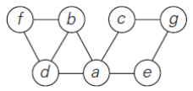

1. Determine the minimum cost spanning tree using Prim’s algorithm for the weighted graph shown

below.

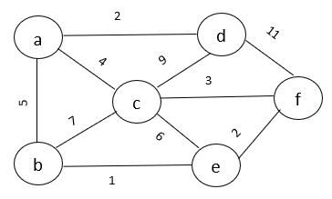

1. Run the Floyd-Warshall algorithm on the weighted, directed graph of figure below. Show the matrix $D^{(k)}$ that results for each iteration of the outer loop.

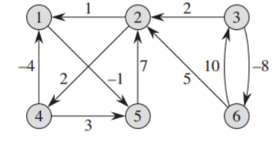

1. Apply the Topological Sort algorithm in the following DAG.

